Chapter V

Control Structures & Boolean Logic

Chapter V Topics

5.1 Introduction
5.2 Types of Control Structures
5.3 Relational Operators
5.4 One-Way Selection
5.5 Two-Way Selection
5.6 Multiple-Way Selection
5.7 Fixed Repetition
5.8 Conditional Repetition
5.9 Control Structures and Graphics
5.10 Nested Control Structures
5.11 Boolean Operators
5.12 Truth Tables
5.13 Compound Conditions
5.14 Program Input Protection
5.15 Short-Circuiting
5.16 Summary
5.1 Introduction

The previous chapter focused on using methods and parameters, which are an integral part of Object Oriented Programming. The intention in Exposure Java is to present OOP in stages. A thorough understanding of Object Oriented Programming is vital in modern computer science. At the same time, you also need to learn the syntax of a programming language. You cannot write proper Java OOP programs unless you know the Java sentence structure or syntax. A prerequisite for a creative writing course is knowledge of spelling and grammar.

Frequently, it is mentioned that programming language syntax is trivial. The essence of programming is design, data structures and algorithms. This is very true, and very lovely, but language syntax tends to be trivial only if you already know syntax. You will get very frustrated with your programs when they do not compile because of syntax problems.

In an earlier chapter we mentioned that program execution follows the exact sequence of program statements. That was true, but also a rather incomplete explanation. There is a lot more to the program flow picture. We can expand on the exact program sequence by stating that program flow follows the sequence of program statements, unless directed otherwise by a Java control structure.

Program Flow
Program Flow follows the exact sequence of listed program
statements, unless directed otherwise by a Java control
structure.

Programs in any computer language require control structures. It may appear that all our program examples were written without the use of any control structures, but the control was subtle. As mentioned earlier, control was provided by a sequence of program statements. That type of control is called simple sequence.

Simple sequence alone is not very satisfactory for programs of any type of consequence. Programs constantly make decisions. A payroll program needs to change the houtrly rate, if the hours exceed 40 per week. The same payroll program can have many variations of tax deductions based on the number of dependents claimed. A payroll program also needs to have the ability to repeat the same actions for additional employees. In other words, a program needs to have the ability to repeat itself, or repeat certain program segments. The language features that allow that type of control will be introduced in this chapter.
5.2 Types of Control Structures

Program-execution-flow is controlled by three general types of control structures. They are simple sequence, selection, and repetition. Java provides syntax, and special keywords for each one of these three control structures. Before we look at the actual Java source code required to implement control, let us first take a look at diagrams that explain each control structure.

Simple Sequence


Program Statement
Program Statement
Program Statement
Program Statement

Simple sequence holds no surprises. A series of program statements are executed in the exact sequence that they are written. Altering the program execution logic requires altering the sequence of the program statements.

Selection

Frequently, programs cannot follow a single, simple sequence, path. Decisions need to be made like should the applicant be hired or not? Does the employee get overtime pay? Which tax bracket is the deduction to be computed from?
Selection is also called conditional branching or decision making. The program flow encounters a special condition. The value of the condition determines if the program flow will “branch off” from the main program sequence. There are three types of selection statements: one-way, two-way and multiple-way. Three diagrams, one for each type of selection, will be shown.

One-Way Selection
Program Statement
Program Statement
Program Statement
Program Statement
Condition
True
False

Selection control structures use a special conditional statement. If the condition is true, some action is performed, such as branching off to another sequence of program statements. In the case of one-way selection, the true condition branches off. If the condition is false, the program flow continues without change in the program sequence.

Consider the analogy of driving South from Dallas to Austin. Along the way you check if your gas tank is low. If the tank is low, you stop for gas, and then continue to Austin. If the tank is not low you continue to drive south. Keep in mind that regardless of the tank condition, you are heading to Austin.

Two-Way Selection


Program Statement
Program Statement
Program Statement
Condition
True
False
Program Statement
Program Statement

The two-way selection control structure also checks to see if some special condition is true. But there is a significant difference in how the program flow is handled. With one-way selection, a true condition means to do something, like get off the road and get gas, before continuing. The two-way selection structure selects one direction, or the other direction, but not both.

The one-way analogy describes a trip traveling south from Dallas to Austin. Regardless of the gas tank situation, the trip travels to Austin in the same car. Now consider an analogy for two-way selection. You are now driving from Austin back to Dallas. The highway you take is I-35 (Interstate 35). When you are about 70 miles from Dallas, shortly after you pass the town of Hillsboro the highway forks. It splits into two roads. You need to decide between going left which means you will take I-35W (Interstate 35 West) to Fort Worth or going right which means you will take I-35E (Interstate 35 East) to Dallas.


Multiple-Way Selection
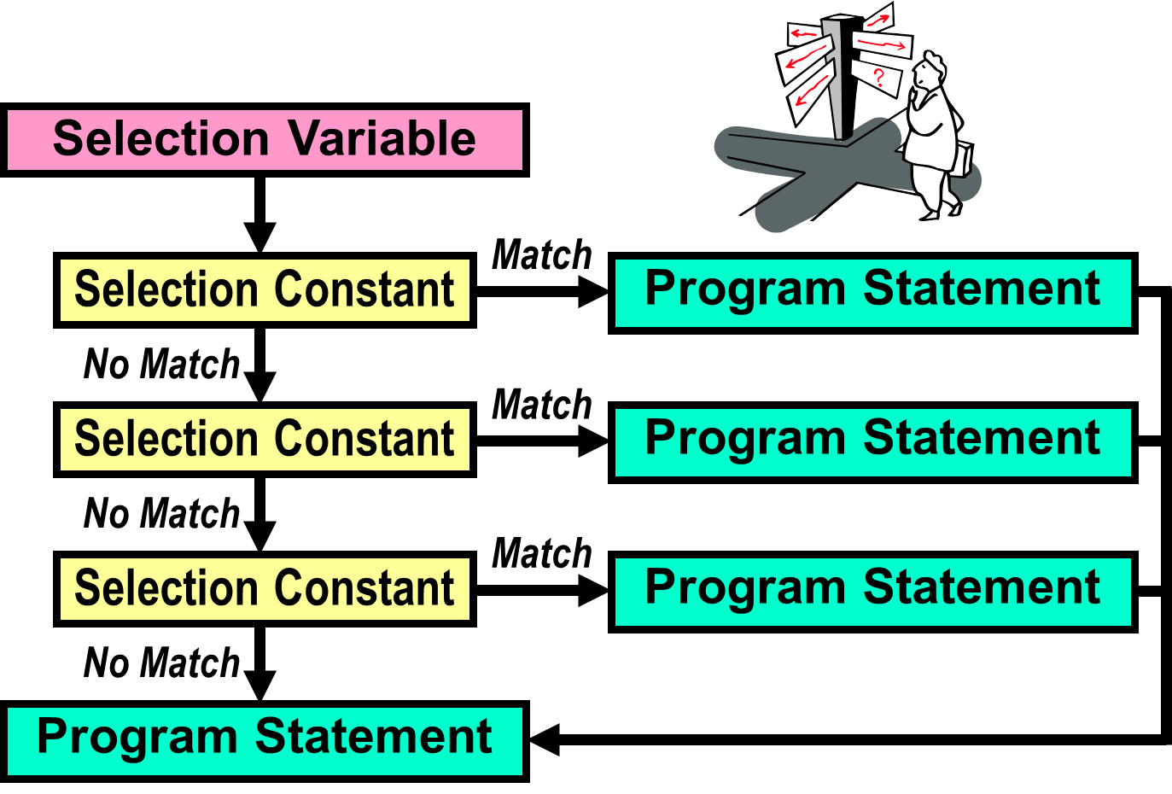

Multiple-way (or Multi-way) selection is a little different from one-way and two-way selection. In this control structure the condition is not very explicit. There is a special selection variable that is used along with several selection constants. The selection variable is compared with each selection constant until a match is found. The condition that you do not really see is if the selection variable equals a particular selection constant. When it finds a match it executes the corresponding program statement.

Multi-way selection is a commonly used control structure that simulates many situations in real life. Many times there are more than 2 things to choose from. For example, do you want chocolate, vanilla, strawberry, pistachio, rocky road, cookies & cream, mint chocolate chip or moo-llennium crunch ice cream for dessert? Do you plan to go to Harvard, Yale, Stanford, Princeton, Texas Tech, UT, OU or some other university? In fact, any time you take a multiple choice test, you are experiencing real life multi-way selection.


Repetition

Another common application occurs when repetition is required. A grade book program needs to average grades for every student in a class of twenty-five students. A payroll program needs to process paychecks for many employees. Practically everything you can imagine is done multiple times. Nobody is interested in repeating program source code 500 times for some task that is to be performed 500 times. We want to create one program segment, and place this segment in some type of loop control structure that repeats 500 times.

Program Statement
Program Statement
Condition
True
False
Program Statement
Program Statement



5.3 Relational Operators

Both the selection control structure diagrams and the repetition diagram indicate a change of program flow occurring after some condition is checked. Understanding conditional statements is the essence of understanding, and using, control structures. However, before we plunge into the syntax of the various conditional statements, you need to understand the relational operators that are used by Java in the conditional statements.

Conditional Statement Definition
A conditional statement is a Boolean program expression, which evaluates to true or false.

Most conditional statements require a relational operator.

All conditions must be placed inside parentheses.

Consider an expression, such as 5 + 4. Does that expression evaluate to true or false? Neither, it evaluates to 9. A relational operator is required to make an expression evaluate to true or false. Java has six relational operators: equals, not equals, greater than, less than, greater than or equal, and less than or equal.
The idea of conditional statements that are based on a relational operator can be considered in regular English statements:

If we save more than $200.00 a month for two years, we can go on a vacation.

If your SAT score is high enough you will be admitted to college, otherwise
you will not be able to go to college.

Repeat calling established customers until you have 25 surveys.

Java Relational Operators

Name | Operator | Expression | Evaluates
Equals | == | 5 == 5  5 == 10 | true  false
Not equals | != | 50 != 25  100 != 100 | true  false
Less than | < | 100 < 200  200 < 100 | true  false
Greater than | > | 200 > 100  200 > 200 | true  false
Less than  or equals | <= | 100 <= 200  200 <= 200  200 <= 100 | true  true  false
Greater than  or equals | >= | 100 >= 200  200 >= 200  200 >= 100 | false  true  true

5.4 One-Way Selection

The simplest control structure is one-way selection. Basically, one-way selection says to perform some indicated action if a condition is true. If the condition is false, continue to march as if the control structure did not exist.

Program Java0501.java, in figure 5.1, computes the year-end bonus for employees of some imaginary company. Every employee automatically gets a $250.00 bonus. However, this company wants to reward its top sales people. The bonus is increased by an additional $500.00 if employee sales are equal to or exceed the half million dollar mark for the year. You will see two outputs for this program, one where the employee earns the extra bonus and one where he does not. This pattern of 2 (or more) outputs will continue with several other programs in this chapter.

Figure 5.6
// Java0501.java
// This program demonstrates one-way selection with <if>.

import java.util.Scanner;

public class Java0501
{
public static void main (String[ ] args)
{
Scanner input = new Scanner(System.in);

int bonus = 250;
System.out.print("Enter Sales ===>> ");
int sales = input.nextInt();

if (sales >= 500000)
bonus += 500;

System.out.println("\nYearly bonus: " + bonus);
}
}

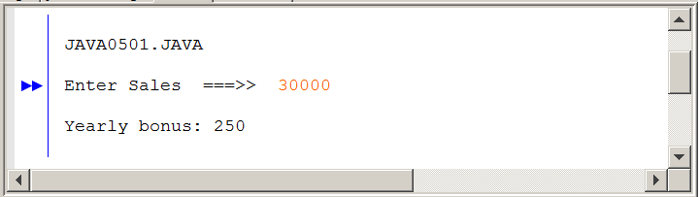
Figure 5.6 Continued
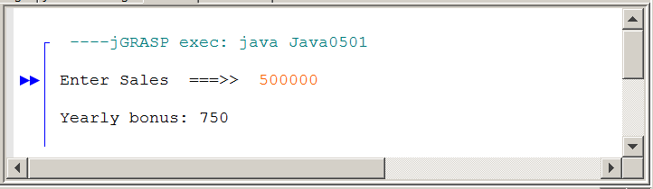

Program Java0501.java, in figure 5.6 uses four statements that are not part of any control structures, but makes testing the program much easier. Much greater details are provided in the next chapter. You will find these four statements used throughout this chapter. The statements are used for program keyboard input. The first new statement is:

import java.util.Scanner;

Import statements are used at the head of a program to give access to one or more classes that are normally not available. The java.util package contains a library of standard Java classes, including the Scanner class. This class makes it possible to enter information from the keyboard during program execution.

The second statement used for keyboard input is:

Scanner input = new Scanner(System.in);

This statement creates the input object. With the input object it will now be possible to use the methods of the Scanner class. You will note that a parameter System.in is used. This means keyboard input. For several chapters you have already used System.out, which is monitor display output.

The third statement used for keyboard input is:

int sales = input.nextInt();

This statement uses the input object with the method nextInt. During program execution, method nextInt will stop the program execution and then sit still patiently waiting for the input of an integer value from the keyboard. The value entered at the keyboard will be assigned to variable sales. Scanner method nextDouble is used for real number input and nextLine for string input.

This is the fourth statement, called the prompt, used for keyboard input:

System.out.print("Enter Sales ===>> ");

Using the prompt gives the program user an indication what is happening. The program stops, presents the message Enter Sales ===>> and then waits patiently for action from the program user. In this case it is indicated that the computer program wants information about sales.

Notes About the Scanner Class
Many programs in this chapter require user-keyboard-input. This is accomplished with the Scanner class using commands:

import java.util.Scanner;
Scanner input = new Scanner(System.in);
int sales = input.nextInt();

Additionally, a prompt needs to be used to indicate what type of information must be entered at the keyboard.

The Scanner class will be explained in great detail in Chapter 6.
For this chapter, the main focus is Control Structures.

Before we look at other control structure program examples, we need to first understand certain items that you will find in all the program examples. In particular, look at the conditional program statement. The conditional expression, (sales >= 500000), is placed inside a set of parenthesis. This is not for looks. Java requires the use of parentheses with all its conditional statements that are used in all of its control structures. The program statement: bonus += 500; is placed below the conditional statement, and it is indented. This is not a Java requirement, but it is a common convention in program development. Both statements below are totally identical from the Java compiler’s point of view. However, you are expected to use the style of the first program segment.

if (sales >=500000)
bonus += 500;

if (sales >=500000) bonus += 500;

The first example places the program statement that will be executed, if the condition is true, indented on the next line. The second example follows the same program logic, but the entire statement is placed on one line. The first example is the more common approach and will be followed in this book.

Using indentations with control structures helps to identify the program statement or statements that will only be executed if the condition is true. You have seen the use of indentation in the main method. You can consider that the braces of the methods control the simple sequence of the program statements.

Indentation Rule
Java syntax uses free-form program style. Program statements may be placed on multiple lines with or without indentation.

By convention, control structures and their conditional statements are placed on one line. The program statement
that is executed, if the condition is true, is placed on the
next line, and indented below the conditional statement.

When two or more program statements are executed, if a conditional statement is true, such statements must be placed between a set of curly braces { } as is shown by program Java0502.java, in figure 5.2. This style of program is called block structure. Java is considered a block structure language. You have already noticed that a Java class and a Java method is contained by an opening curly { brace and a closing curly } brace.

Figure 5.2
// Java0502.java
// This program demonstrates one-way selection
// using curly "container" braces to create block structure.

import java.util.Scanner;

public class Java0502
{
public static void main (String[ ] args)
{
Scanner input = new Scanner(System.in);

int bonus = 250;
System.out.print("Enter Sales ===>> ");
int sales = input.nextInt();
System.out.println();

if (sales > 500000)
{
bonus += 500;
System.out.println("Your sales are greater than $500,000.");
System.out.println("You will receive an extra $500 bonus.");
}
System.out.println("Total Yearly bonus: " + bonus);
}
}

Figure 5.2 Continued
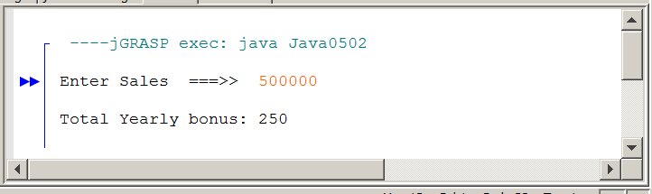

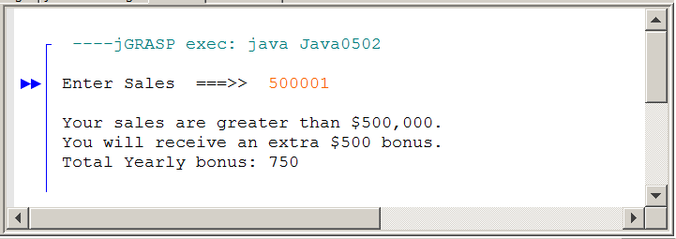

Program Java0501.java contains the statement if (sales >= 500000). Program Java0502.java contains the statement if (sales > 500000). The subtle difference is >= vs >. If you refer to the output of the earlier program, you will see that $500,000 was sufficient to earn to bonus. In the latter program it is not.

One-Way Selection
if the condition is true
execute the program statement(s)

Specific Examples:

if (counter > 100)
System.out.println("Counter exceeds 100");

Use braces { } and block structure to control multiple
program statements.

if (savings >= 10000)
{
System.out.println("It’s skiing time");
System.out.println("Let’s pack");
System.out.println("Remember your skis");
}

5.5 Two-Way Selection

A slight variation of one-way selection is two-way selection. With two-way selection there are precisely two paths. The computer will either take one path, if the condition is true, or take the other path if the condition is false. It is not necessary to check a conditional statement twice. The reserved word else makes sure that the second path is chosen when the conditional statement evaluates to false. The program example that follows is very short. The program considers the value of a student’s SAT score. College admission is granted or denied based on the SAT score. Note the indentation style of the if ... else control structure that is shown in figure by Java0503.java, in figure 5.3.
Figure 5.3
// Java0503.java
// This program demonstrates two-way selection with <if..else>.

import java.util.Scanner;

public class Java0503
{
public static void main (String[ ] args)
{
Scanner input = new Scanner(System.in);

System.out.print("Enter your SAT score. --> ");
int sat = input.nextInt();
System.out.println();

if (sat >= 1100)
System.out.println("You are admitted");
else
System.out.println("You are not admitted");
}
}

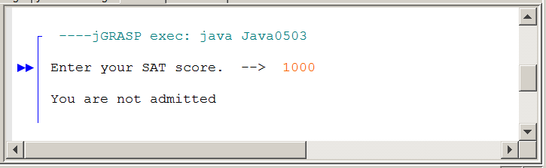

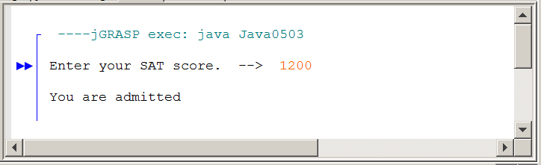

Program Java0504.java, in figure 5.4, demonstrates block structure with two-way selection. The same type of SAT program is shown with a few statements added to help demonstrate the block structure. Pay attention to the style that is used with the block structure and the if ... else. You will notice different styles in different books. This is fine, as long as the style is consistent.
Figure 5.10
// Java0504.java
// This program demonstrates two-way selection with
// curly braces block-structure.

import java.util.Scanner;

public class Java0504
{
public static void main (String[ ] args )
{
Scanner input = new Scanner(System.in);
System.out.print("Enter your SAT score. --> ");
int sat = input.nextInt();
System.out.println();

if (sat >= 1100)
{
System.out.println("Your SAT score of " + sat);
System.out.println("meets our expectations.");
System.out.println("You are admitted");
}
else
{
System.out.println("Your SAT score of " + sat);
System.out.println("does not meet our expectations.");
System.out.println("You are not admitted");
}
}
}

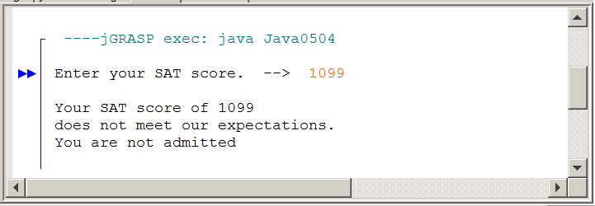
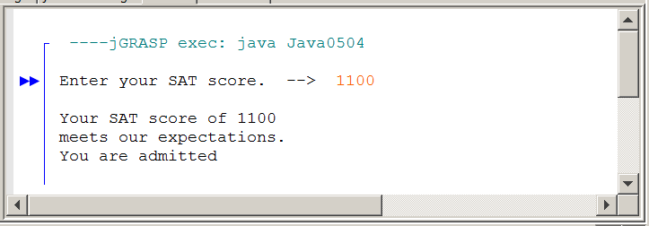
Two-Way Selection
if the condition is true
execute the first program statement or first block
else if the condition is not true
execute the second program statement or second block

Specific Example:

if (gpa >= 90.0)
System.out.println ("You’re an honor graduate");
else
System.out.println ("You’re not an honor graduate");

5.6 Multiple-Way Selection

The final selection structure needs to be watched carefully. Multiple-Way Selection is very useful, but can cause problems if you are not aware of certain peculiar quirks that lurk in Java.

Multiple-Way Selection occurs whenever you have more than 2 choices. The next program example asks the user to enter an integer between 1 and 12. Each number is associated with a particular month. The multi-way selection structure does not use the conditional statement logic of the if structures. Multi-way selection is accomplished with the switch command which uses a selection variable with a value. The selection variable value is compared with a group of designated case values. When a match is found, the statements following the case value are executed. Look at the syntax of program Java0505.java, in figure 5.05, and observe two new Java keywords, switch, and case.

Figure 5.5
// Java0505.java
// This program demonstrates multi-way selection with <switch> and <case>.
// This program compiles, but displays illogical output.

import java.util.Scanner;

public class Java0505
{
public static void main (String[ ] args)
{
Scanner input = new Scanner(System.in);
System.out.print("Enter month number. [1..12] --> ");
int month = input.nextInt();
System.out.println();

switch (month)
{
case 1 : System.out.println("January");
case 2 : System.out.println("February");
case 3 : System.out.println("March");
case 4 : System.out.println("April");
case 5 : System.out.println("May");
case 6 : System.out.println("June");
case 7 : System.out.println("July");
case 8 : System.out.println("August");
case 9 : System.out.println("September");
case 10 : System.out.println("October");
case 11 : System.out.println("November");
case 12 : System.out.println("December");
}
}
}

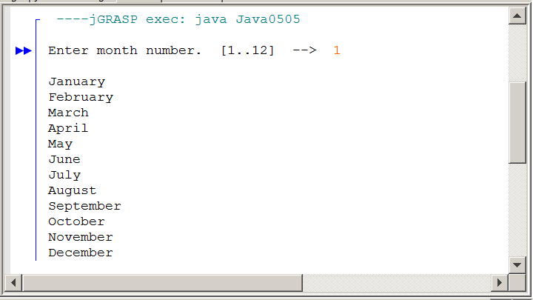

Figure 5.5 Continued
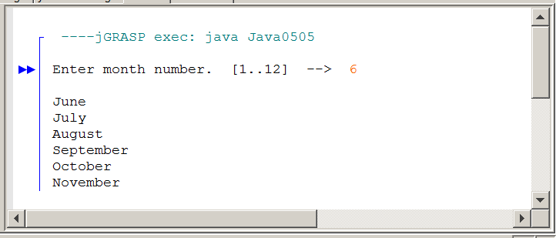
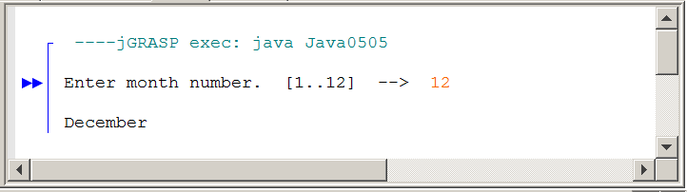

The switch structure in the Java0505.java program example only works with certain data types. hese are int, char and String. switch does not work with double or boolean. In this case month is an int and it is also the selection variable that determines the matching process. Note that month is placed between the parentheses of the switch structure.

With switch there are usually at least 3 possible outcomes. Each of the possible outcomes starts with the reserved word case, followed by a constant value that could be a possible match for the selection variable. A colon ( : ) is required to separate the selection constant from the program statement that needs to be performed if a match is found.

Alright, we get the syntax, but what is the deal with the output? Most people would have expected to see just “January” when 1 was entered. Instead we see everything. When 6 is entered we see “June” and everything after it. The only time the output seems logical is when 12 is entered. Please do realize that nothing is wrong. The switch statement behaves exactly the way that it was designed for Java. Be aware of that and make sure that you handle your programs accordingly. Program execution will compare each case with the selection variable, and the moment a match is made the program flow branches off. Now keep in mind that not only the program statement of the matching case statement executes, but every program statement in the entire switch block that follows.
Program Java0506.java, shown in figure 5.6, cures the problem of the previous switch example. You will notice a new Java keyword has been added to every case statement. It is break, and it is placed between every case statement. break exits the current program block, which in this case means that program execution jumps to the end of the main method. Technically, you can use break in other situations to make various jumps to different program segments. For our purposes, we will only use break with multiple selection.

What would happen if someone entered an invalid month number like 13? The previous program would not have displayed anything. It is certainly more user-friendly to inform the user that they have made a mistake. To handle this Java has a special default case. If none of the other cases are matched, Java will execute the default case. In general, default is what a computer executes when nothing is specified. It should make sense that default case does not need a break statement since it is already at the end of the switch structure. The program outputs are now logically correct.

Figure 5.6
// Java0506.java
// This program demonstrates multi-way selection with <switch> and <case>.
// This program adds <break> and <default>.
// The use of <break> is required for logical output.

import java.util.Scanner;

public class Java0506
{
public static void main (String[ ] args)
{
Scanner input = new Scanner(System.in);
System.out.print("Enter month number. [1..12] --> ");
int month = input.nextInt();
System.out.println();

switch (month)
{
case 1 : System.out.println("January"); break;
case 2 : System.out.println("February"); break;
case 3 : System.out.println("March"); break;
case 4 : System.out.println("April"); break;
case 5 : System.out.println("May"); break;
case 6 : System.out.println("June"); break;
case 7 : System.out.println("July"); break;
case 8 : System.out.println("August"); break;
case 9 : System.out.println("September"); break;
case 10 : System.out.println("October"); break;
case 11 : System.out.println("November"); break;
case 12 : System.out.println("December"); break;
default : System.out.println("This is not a valid month number.");
}
}
}
Figure 5.6 Continued
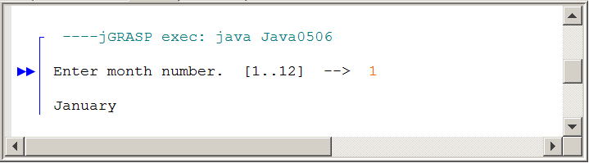
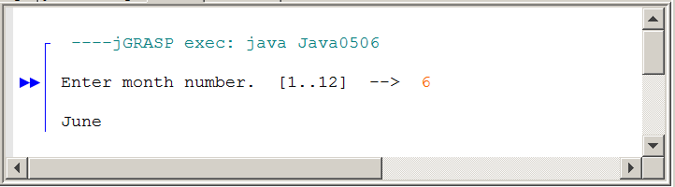
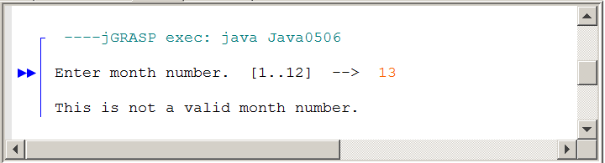

Multiple-Way Selection
Specific Example:

switch(courseGrade)
{
case 'A' : points = 4; break;
case 'B' : points = 3; break;
case 'C' : points = 2; break;
case 'D' : points = 1; break;
case 'F' : points = 0; break;
default : points = 0;
}

5.7 Fixed Repetition

We now make a major jump in the control structure department. We have just looked at three control structures. All three control structures were different but they each were some type of selection control. Now you will learn how to repeat program segments.

The title of this section is repetition. That is not the only word. You can also say looping, and the formal computer science word is iteration. The name does not matter, as long as you realize that this is a control structure that executes certain program segments repeatedly.

The Java language has three different types of iterative control structures. In this section we will explore fixed iteration with the for loop structure. Fixed means that the number of times that a program segment repeats, is fixed. You can look at the code of the loop structure and determine how many items it will repeat. It is not necessary to run the program to determine that.

Program Java0507.java, in figure 5.7, is quite short. There is lots of output with very little program code. How is the repetition accomplished? Ah . . . with the special magic of the for loop structure. The only new keyword in the repetition program is the for statement. Right now focus strictly on that statement. The only part that looks familiar is a set of parenthesis, which you have already seen in use by previous control structures.

Figure 5.7
// Java0507.java
// This program displays 60 identical lines efficiently
// with one println statement and a loop structure.
public class Java0507
{
public static void main(String[ ] args)
{
int k;
for (k = 1; k <= 60; k++)
System.out.println("Eat at Joe's friendly diner for the best lunch value");
}
}

Figure 5.7 Continued
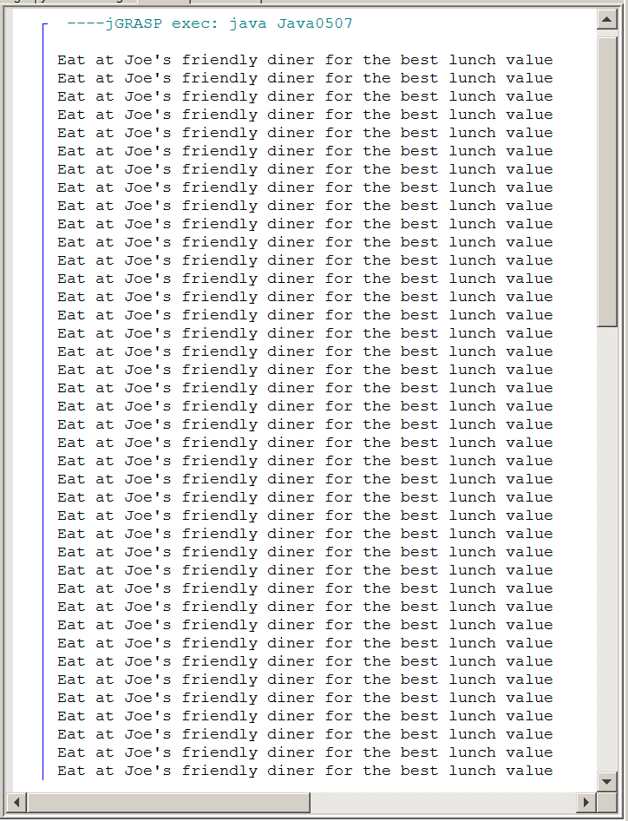
The for loop structure consists of three distinct parts, shown below, that work together to control the program flow.

for (k = 1; k <= 40; k++)

Part 1 initializes the Loop Control Variable (LCV), which in this case means that k starts with the value of 1.

Part 2 states the Loop Entry Condition. As long as the value of k is less than or equal to 40, the program statement following the for parenthesis will be executed.

Part 3 indicates the manner in which the Loop Control Variable is altered. In this case the value of k is incremented by 1 each time through the loop.

The next program example, in figure 5.8, demonstrates that the LCV can handle two jobs at the same time. In this program the LCV checks that the program statement is repeated 15 times. In addition, the LCV also serves as a counter because the value of the LCV is displayed each time the loop structure statement is executed. This program also shows a common Java convention to define a variable at the same place where the variable is initialized.

Figure 5.8
// Java0508.java
// This program displays consecutive numbers 1 through 15.
// It also shows how the loop control variable may be
// defined inside the <for> program statement.
public class Java0508
{
public static void main(String[ ] args)
{
for (int k = 1; k <= 15; k++)
System.out.print(k + " ");
}
}

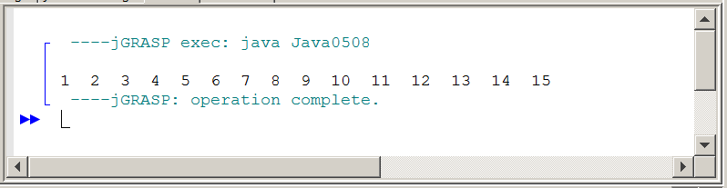
Program Java0509.java, in figure 5.9, is a slight variation on the previous program. This program demonstrates how to execute multiple statements in a loop control structure. Yes, you guessed it, your good friend block structure with braces { } is back to save the day. Try this program out and comment out the braces to see the result.

Figure 5.9
// Java0509.java
// This program demonstrates how to use block structure
// with a <for> loop control structure.
public class Java0509
{
public static void main(String[ ] args)
{
int k;
for (k = 1; k <= 5; k++)
{
System.out.println("####################");
System.out.println("Line Number " + k);
}
}
}

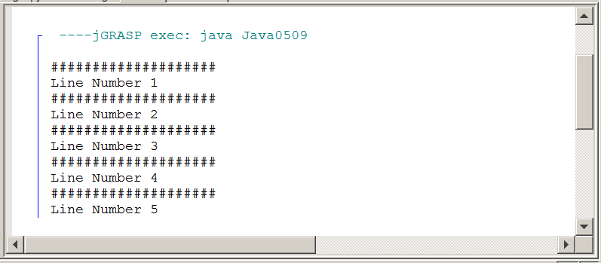

You may get the impression that the for loop uses a Loop Control Variable (LCV) that always increments by 1. This is not always true. Program Java0510.java, in figure 5.10, has five separate loop control structures. Each loop uses a different incrementer.

The first loop uses p++, and increments by 1. This is old news and the loop structure displays numbers from 1 to 15.

The second loop uses q+=3, and increments by 3. This loop structure displays numbers 1, 4, 7, 10, 13.

The third loop uses r-- and this loop does not increment at all; it decrements the LCV by 1 each time. This control structure displays the numbers from 15 to 1.

The fourth loop uses s+=0.5 and increments in fractional amounts. This loop structure displays numbers from 0 to 3.0.

The fifth loop uses t++, with t as a char and increments one character letter each time. This loop structure displays letters A to Z.

Figure 5.10
// Java0510.java
// This program displays various counting schemes.
// It also demonstrates the versatility of the <for> loop.
public class Java0510
{
public static void main(String[ ] args)
{
for (int p = 1; p <= 15; p++)
System.out.print(p + " ");
System.out.println("\n");
for (int q = 1; q <= 15; q+=3)
System.out.print(q + " ");
System.out.println("\n");
for (int r = 15; r >= 1; r--)
System.out.print(r + " ");
System.out.println("\n");
for (double s = 0; s <= 3; s+=0.5)
System.out.print(s + " ");
System.out.println("\n");
for (char t = 'A'; t <= 'Z'; t++)
System.out.print(t + " ");
}
}

Figure 5.10 Continued
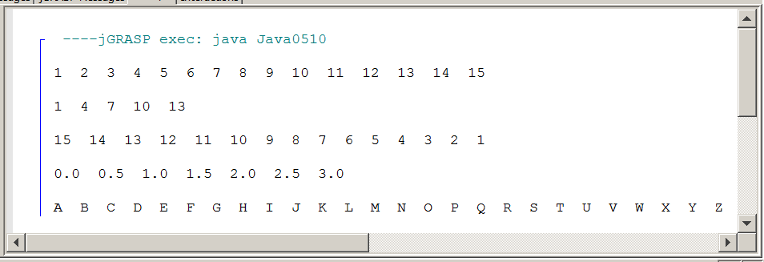

Fixed Repetition
for (Part1; Part2; Part3)
loop body;

The for loop has three distinct parts:

Part1 initializes the Loop Control Variable (LCV).
Part2 sets the exit condition for the loop.
Part3 determines how the LCV changes.

Specific Examples:

for (k = 1; k <= 10; k++)
System.out.println("Java is 10 times more fun");

Just like the if statement, use braces { } and block structure to control multiple program statements.

for (k = 20; k >= 0; k- -)
{
System.out.println("Rocket Launch Countdown");
System.out.println( );
System.out.println("T minus " + k + " seconds.");
System.out.println( );
}

5.8 Conditional Repetition

Fixed iteration is not always possible. There are too many situations where it is established that repetition will take place, but it is not known how frequently something will be repeated. The entry of a password can be correct the first time or it may take many repeated attempts before the correct password is entered. Another situation may be based on time, which means that somebody who uses the computer slowly gets few repetitions and a fast operator gets many repetitions. Video games frequently repeat the same scene, but this repetition is usually not based on a fixed amount. Video games rely more on number of lives left. I think you get the picture. Computer life is full of situations with unknown repetitions. Java is well prepared for the task with two conditional loop structures: The precondition while loop and the postcondition do...while loop.

Note to Teachers and Students with Advanced Knowledge
It is possible to treat the for loop structure like a conditional loop that is not fixed. In fact, a for loop can be designed to behave exactly like a while loop.

It is my intention to use and treat a for loop like a fixed iteration
loop and use the while loop and do...while loop for other repetition situations.

This approach is less likely to cause confusion. At some later
date, when you are comfortable with all the control structures,
you can use them in any appropriate manner.

If this does not make sense to you, do not worry.
Ignore this little summary box, and move on.

The Precondition while Loop

Program Java0511.java, in figure 5.11, introduces the while loop. This loop is called a precondition loop. The condition, which determines when the loop exits, is tested before the loop body is started. Like earlier control structures, you will note that the condition is placed inside a set of parenthesis.

The while loop structure requires a statement inside the loop body that was not necessary with the for loop. The purpose of this statement is to give an opportunity for the loop control variable to change. The for loop includes a component in the loop heading that increments the loop counter by some specified amount. There is no equivalent component in the while loop. Only the loop condition is checked.

Figure 5.11
// Java0511.java
// This program demonstrates the precondition <while> loop.
// This loop will continue until the loop condition is false.
public class Java0511
{
public static void main(String[ ] args)
{
int number = 0;
while (number <= 10)
{
System.out.println("Number: " + number);
number++;
}
}
}

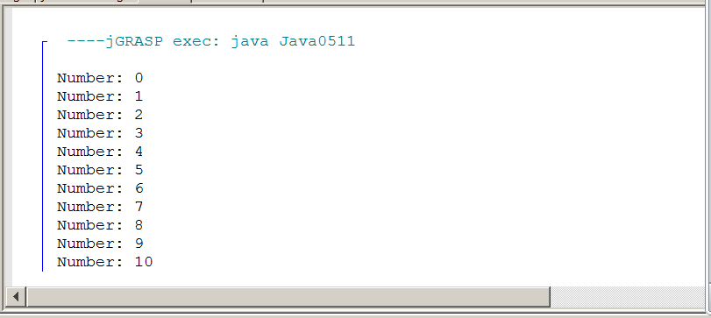
Pre-Conditional Repetition
initialize condition variable before the while loop
while(condition is true)
{
loop body
alter condition variable in the loop body
}

Specific Example:

int pin = 0; // initialize condition variable
while(pin != 5678)
{
System.out.print("Enter pin. ===>> ");
pin = input.nextInt(); // alter condition variable
}
System.out.println("Welcome.");

Failure to handle the loop condition variable can bring about bizarre results, including an infinite loop program execution. Carefully hard code the following nono and yesyes program segments, of figures 5.12 and 5.13, in your brain.

Figure 5.12
Program Segment NoNo #1 | Program Segment YesYes #1
int x = 0;  while(x < 10)  System.out.println(x);  The loop condition variable, x, never changes.  The loop will not exit. | int x = 0;  while(x < 10)  {  x++;  System.out.println(x);  }  The loop condition variable, x, changes.  The loop exits when x reaches 10.

Figure 5.13
Program Segment NoNo #2 | Program Segment YesYes #2
int x;  while(x < 10)  {  x++;  System.out.println(x);  }  The loop condition variable, x, is never initialized.  This program will not compile. | int x = 0;  while(x < 10)  {  x++;  System.out.println(x);  }  The loop condition variable, x,  is initialized. The program will compile and execute correctly.

The Postcondition do...while Loop

Program Java0512.java adds a small change to the conditional loop business with the keyword do. The body of the loop is placed between the starting do keyword, and the closing while condition. Since the condition of the loop exit is tested at the conclusion of the loop body, the loop is called postcondition. Program Java0512.java, in figure 5.14, checks to see if the PIN (Personal Identification Number) at an ATM (Automatic Teller Machine) is entered correctly.

The conditional loop in this program allows an unending number of tries to enter the correct PIN number. This is not realistic in the real world. After three or four attempts the card would be confiscated and the account locked.

Figure 5.23
// Java0512.java
// This program demonstrates the postcondition <do..while> loop.
// This loop structure guarantees at least one repetition of
// the loop body. Like the <while> loop this is not a
// "fixed iteration" loop.

import java.util.Scanner;

public class Java0512
{

public static void main(String[ ] args)
{
Scanner input = new Scanner(System.in);
System.out.println("Please enter your ATM Personal Identification Number (PIN)!");
System.out.println();
int pin = 0;

do
{
System.out.print("Enter your PIN ==>> ");
pin = input.nextInt();
System.out.println();
if (pin != 1234)
System.out.println("That is not the correct PIN.");
System.out.println();
}
while (pin != 1234);

System.out.println("Your PIN is correct; you may proceed.");
}
}

Figure 5.23 Continued
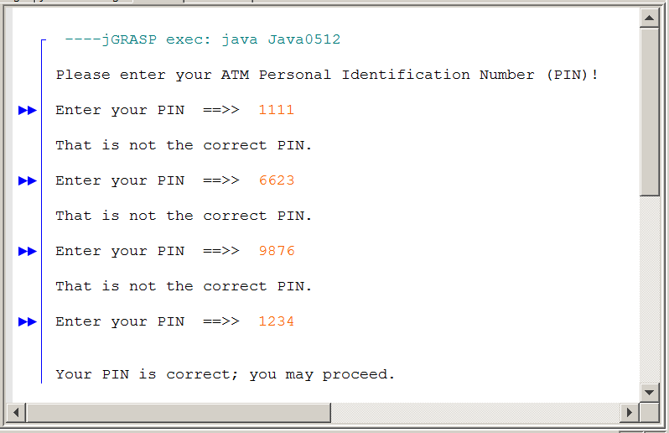

Post-Conditional Repetition
initialize condition variable before the do..while loop
do
{
loop body
alter condition variable in the loop body
}
while(condition is true)

Specific Example:

int pin = 0; // initialize condition variable
do
{
System.out.print("Enter pin. ===>> ");
pin = input.nextInt(); // alter condition variable
}
while(pin != 5678); // Not a heading, Semicolon is required.
System.out.println("Welcome.");

Fixed Repetition vs. Conditional Repetition
Fixed Repetition describes a situation where you know – ahead of time – how many times you want the loop to repeat.

An example would be drawing exactly 100 circles on the screen.

The command for fixed repetition is for.

Conditional Repetition describes a situation where you may NOT know how many times the loop will repeat.

The loop has to repeat until some condition is met.

An example would be entering a password.

The command for pre-conditional repetition is while.

The commands for post-conditional repetition are do..while.

AP® Examination Alert for Selection Control Structures
The one-way selection if is tested on the AP® Exam.
if (sales >= 500000)
bonus = bonus + 5000.0;

The two-way selection if..else is tested on the AP® Exam.
if (sat >= 1200)
System.out.println("You're admitted");
else
System.out.println("You're not admitted");

The multi-way selection switch..case..break is not tested
on the AP® Exam.
switch (grade)
{
case 'A' : gpaPoints = 4; break;
case 'B' : gpaPoints = 3; break;
case 'C' : gpaPoints = 2; break;
case 'D' : gpaPoints = 1; break;
case 'F' : gpaPoints = 0;
}

AP® Examination Alert for Repetition Control Structures
The fixed-repetition for loop is tested on the AP® Exam.
for (int k = 1; k <= max; k++)
sum += k;

The pre-condition while loop is tested on the AP® Exam.
while (k < max)
{
sum += k;
k++;
}

The post-condition do..while loop is not tested on the AP® Exam.
do
{
sum += k;
k++;
}
while (k < max);

5.9 Control Structures and Graphics

Java has many very nice graphics features. You learned some of the graphics capabilities in the last chapter. In this section you will investigate some more graphics program capabilities. However, there is a major difference. In the last chapter you learned how to use many methods that were part of the Graphics class. Graphic displays are not simply a matter of calling the right method for the right purpose. You can also perform some neat tricks by using control structures. Control structures combined with graphic method calls can have some very nice visual effects.

Program Java0513.java, in figure 5.15, starts nice and simple by drawing vertical lines that are 10 pixels apart. Note that y1 and y2 values, which control the top-down values, are fixed at 100 and 500. With the help of a control structure you can draw many lines with a single drawLine statement.

Figure 5.15
// Java0513.java
// This program shows how a control structure can be used with graphics.
// This program draws vertical lines, because x1 and x2 have the same value.
import java.awt.*;
import java.applet.*;
public class Java0513 extends Applet
{
public void paint(Graphics g)
{
int y1 = 100;
int y2 = 500;
for (int x = 50; x < 700; x +=10)
g.drawLine(x,y1,x,y2);
}
}

Figure 5.15 Continued
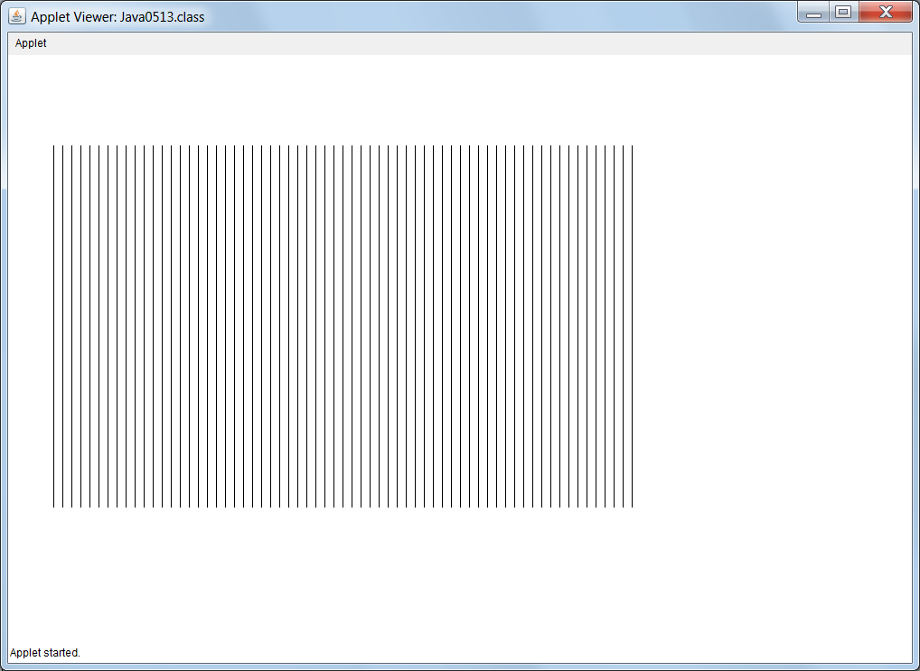

Program Java 0514.java, in figure 5.16, makes a few small changes to the previous program to draw horizontal lines. This time x1 and x2 are fixed values.

Figure 5.16
// Java0514.java
// This program shows how a control structure can be used with graphics.
// This program draws horizontal lines, because y1 and y2 have the same value.
import java.awt.*;
import java.applet.*;
public class Java0514 extends Applet
{
public void paint(Graphics g)
{
int x1 = 100;
int x2 = 700;
for (int y = 50; y < 500; y +=10)
g.drawLine(x1,y,x2,y);
}
}

Figure 5.16
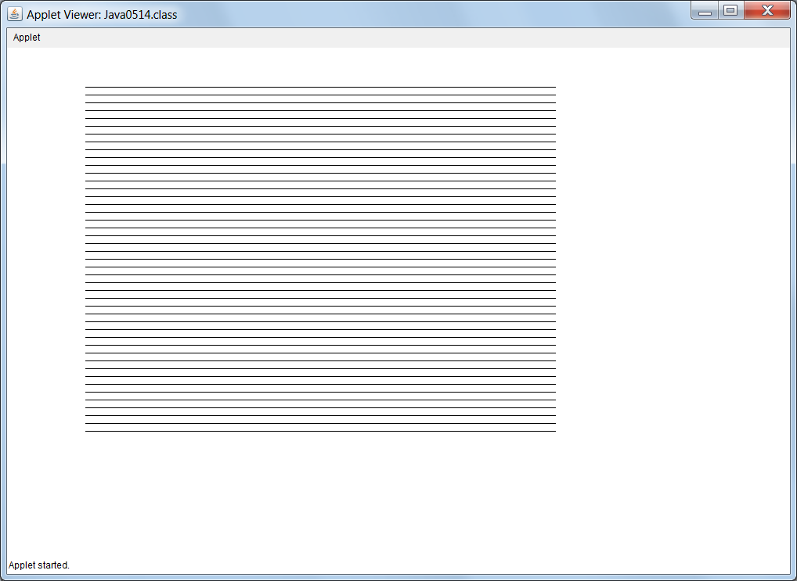

Program Java0515.java, in figure 5.17, plays another twist with straight lines. This time it is not a set of x values or a set of y values that change, but one coordinate point changes with each repetition.

Right now try and change variables, especially the (x,y) coordinates in various ways and check the impact on the program execution.

Personally, I call this playing with the program. This type of play teaches you an amazing amount about a program language and the logic of programming. What changes do you make? Be creative. Some changes may actually cause syntax errors. That is instructive and helps you understand the proper grammar or program syntax of a language. Other changes are logical and help you understand how program output changes with program logic.

Figure 5.17
// Java0515.java
// This program demonstrates how to rotate a line around a point.
// In this case the (x1,y1) coordinate stays fixed and the (x2,y2) point changes.
import java.awt.*;
import java.applet.*;
public class Java0515 extends Applet
{
public void paint(Graphics g)
{
int x1 = 50;
int y1 = 50;
int x2 = 600;
int y2 = 50;
for (int k = 1; k < 50; k++)
{
g.drawLine(x1,y1,x2,y2);
y2 += 10;
}
}
}

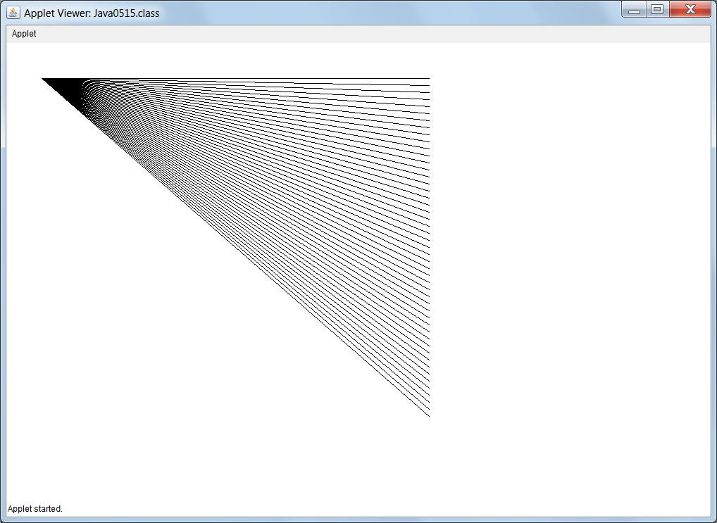

You can create an interesting effect by displaying multiple rectangles in a loop while changing the top-left coordinate values along with the size of the rectangles. Java0516.java, in figure 5.18, uses a k loop control variable to repeat twenty-five calls to drawRect. The values for x, y and side change to grow the squares.

Figure 5.18
// Java0516.java
// This program is example of displaying multiple graphics rectangles
// using a loop control structure.
import java.awt.*;
import java.applet.*;
public class Java0516 extends Applet
{
public void paint(Graphics g)
{
int x = 375;
int y = 275;
int side = 50;
for (int k = 1; k <= 25; k++)
{
g.drawRect(x,y,side,side);
x -= 10;
y -= 10;
side += 20;
}
}
}

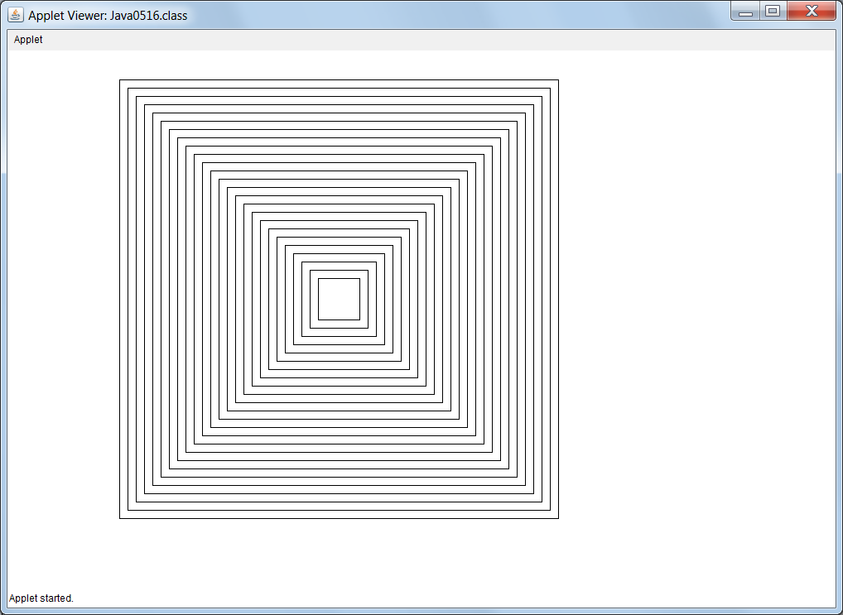
Java0517.java, in figure 5.19, demonstrates a square filled with straight lines. Each line travels through the center of the square in such a manner that all the lines intersect through the same point.

Figure 5.19
// Java0517.java
// This program create an interesting pattern.
import java.awt.*;
import java.applet.*;
public class Java0517 extends Applet
{
public void paint(Graphics g)
{
g.drawRect(50,50,500,500);
for (int x = 50; x <= 550; x += 10)
g.drawLine(x,50,600-x,550);
for (int y = 50; y <= 550; y += 10)
g.drawLine(50,y,550,600-y);
}
}

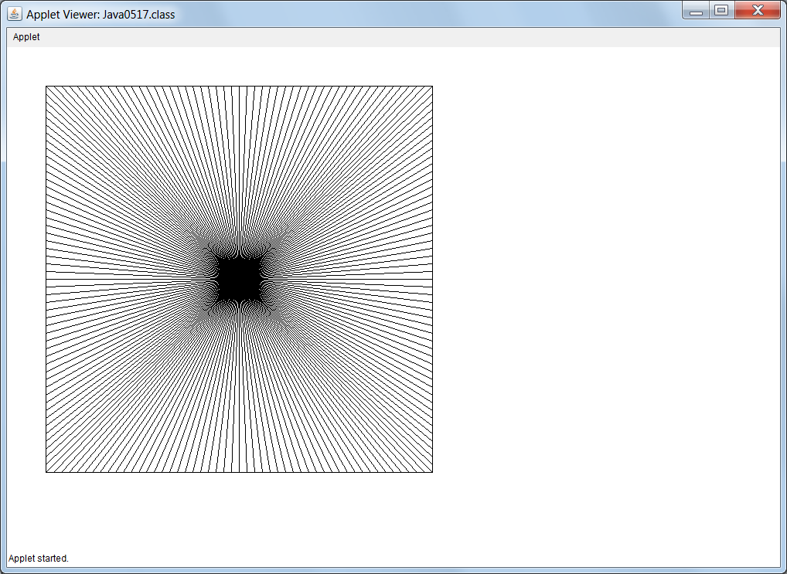

5.10 Nested Control Structures

Nested control structures may look complex, but the logic is identical. There are more conditional statements than with simple control structures. Program Java0518.java, in figure 5.20, show two if..else structures nested inside a large if..else statement. Indentation becomes very important to help clarify the start and end of each control structure.

Figure 5.20
// Java0518.java
// This program demonstrates nesting an <if..else> structure inside another <if..else> structure.
// This will determine if a student is eligible for financial aid.
// Note that this is not an issue for students whose SAT scores are below 1100.

import java.util.Scanner;

public class Java0518
{
public static void main (String[ ] args)
{
Scanner input = new Scanner(System.in);

System.out.print("Enter SAT ===>> ");
int sat = input.nextInt();
System.out.println();

if (sat >= 1100)
{
System.out.println("You are admitted");
System.out.println("Orientation will start in June");

System.out.println();
System.out.print("What is your family income? ===>> ");
int income = input.nextInt();
System.out.println();

if (income <= 20000)
{
System.out.println("You qualify for financial aid.");
}
else
{
System.out.println("You do not qualify for financial aid.");
}
}
else
{
System.out.println("You are not admitted");
System.out.println("Please try again when your SAT improves.");
}
}
}

Figure 5.20 Continued
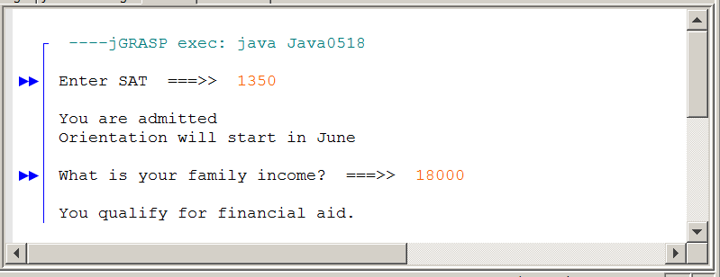
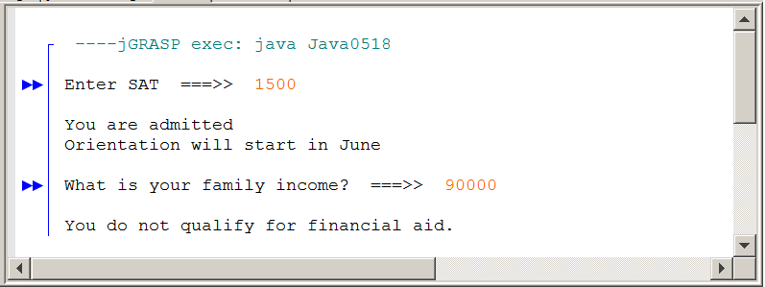
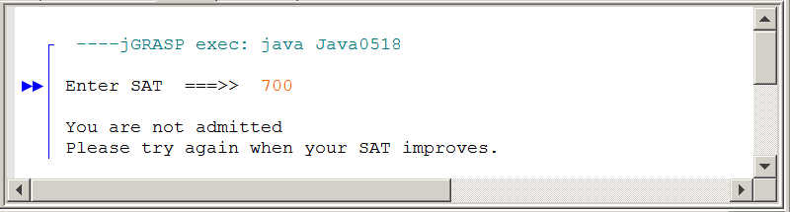

Notice that the financial aid question is not even asked if the student’s SAT score is not high enough. Financial aid is irrelevant if the student was not accepted in the first place. This works because the entire if…else structure that deals with financial aid is nested inside the if block that deals with having an SAT score that is high enough.

A different style of indentation is used when there are a large number of nested else statements. Program Java0509.java, in figure 5.21, converts numbers in a numerical range to a letter grade. This is frequently called a sequence of else if program statements. Some would call this resembles multi-way selection.
Figure 5.21
// Java0519.java
// This program determine your graduation status based on your college GPA
// using multiple nested <if..else> statements.
// This is necessary because <switch> only works with integers, characters and strings.

import java.util.Scanner;

public class Java0519
{
public static void main (String[] args)
{
Scanner input = new Scanner(System.in);
System.out.print("Enter GPA ===>> ");
double gpa = input.nextDouble();
System.out.println();

if (gpa >= 3.9)
System.out.println("Summa Cum Laude");
else if (gpa >= 3.75)
System.out.println("Magna Cum Laude");
else if (gpa >= 3.5)
System.out.println("Cum Laude");
else if (gpa >= 2.0)
System.out.println("Graduate without honors");
else
System.out.println("Will not graduate");

System.out.println();
}
}

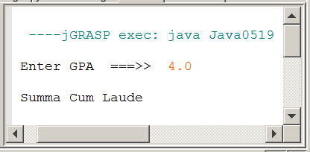 | 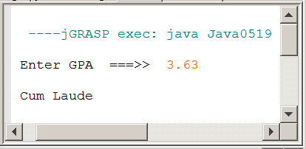
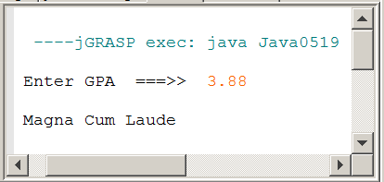 | 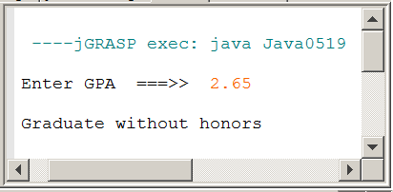

Loop structures can also be nested. Program Java0520.java, in figure 5.22, displays three multiplication tables. The inner loop displays an individual table and the outer loop determines how many, and which tables will be displayed.

Figure 5.22
// Java0520.java
// This program displays several multiplication tables using
// a nested <for> loop structures.
public class Java0520
{
public static void main(String[] args)
{
for (int table = 11; table <= 13; table++)
{
for (int k = 1; k <= 5; k++)
{
System.out.println(k + " * " + table + " = " + k * table);
}
System.out.println();
}
}
}

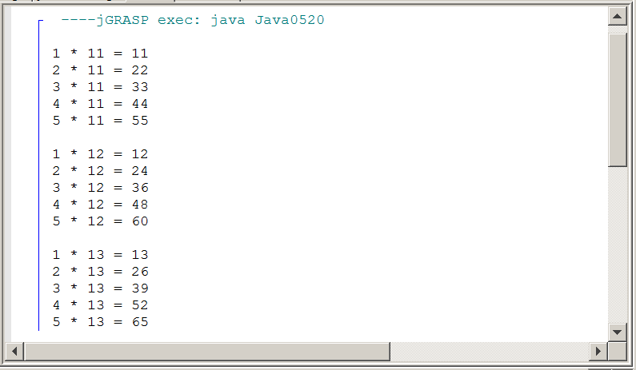

Program Java0521.java, in figure 5.23, shows a set of nested pre-condition loop with while. The output is identical to the previous program.

Figure 5.23
// Java0521.java
// This program displays several multiplication tables using
// nested pre-condition <while> loop structures.
public class Java0521
{
public static void main(String[] args)
{
int k = 1;
int table = 11;
while (table <= 13)
{
while (k <= 5)
{
System.out.println(k + " * " + table + " = " + k * table);
k++;
}
System.out.println();
k = 1;
table++;
}
}
}

5.11 Boolean Operators

In this section we will look at four different Boolean operators. You know how to handle arithmetic operators ( + - * / % ). Addition, subtraction, multiplication, division and remainder operations are performed according to the rules for each operator. There are also a set of Boolean operators with their own set of rules. The rules of Boolean operators can be conveniently displayed in a truth table. This is a table, which shows the possible combinations of Boolean statements and indicates the value (true or false) of each statement. Remember that a Boolean statement is either true or false.
In the truth tables that follow, a single letter indicates a single, simple Boolean condition. Such a condition is either true or false. Boolean statement A is true or false. Likewise Boolean statement B is true or false. The truth tables will show the results of Boolean statements that use both A and B with a variety of Boolean operators. Employment requirements will be used to explain the logic of each truth table. In each case imagine that an accountant needs to be hired. Condition A determines if the applicant has a Degree and condition B determines if the applicant has at least five years' experience.

Boolean Or

The or Operator
A | B | A or B
T | T | T
T | F | T
F | T | T
F | F | F

Notice that two conditions have four possible combinations. It is important that you know the results for each type of combination. In this case the employment analogy requires a Degree OR Experience. This requirement is quite relaxed. You have a Degree, fine. You have Experience, that’s also fine. You have both, definitely fine. You have neither, that’s not fine and causes a problem.

Boolean And

The and Operator
A | B | A and B
T | T | T
T | F | F
F | T | F
F | F | F

Now employment requires a Degree AND Experience. This requirement is much more demanding than the or operator. You have a Degree, fine, provided you also have Experience. If you have only one qualification, or the other qualification, that is not good enough.

Boolean Xor

The xor Operator
A | B | A xor B
T | T | F
T | F | T
F | T | T
F | F | F

English, uses both the or operator, as well as the and operator in communication. The use of xor is another story. A peek at the truth table shows if conditions A and B are both true, the compound result is false. I will try to explain this by using the “cheap boss” analogy. A manager wants to hire somebody and not pay much money. The advertisement states that a degree or experience is required.

Candidate X walks in and the boss says: “I’ll hire you, but your pay will be low. You see, you have a degree but you have no experience at all.”

Candidate Y walks in and the boss says: “I’ll hire you, but your pay will be low. You see, you have experience but you have no degree.”

Candidate Z walks in and the boss says: “I’m sorry I cannot hire you. You are over qualified since you have a degree and also experience.”

Boolean Not

The not Operator
A | not A
T | F
F | T

This section will finish with the simplest Boolean operator, not. This operator takes the condition that follows and changes true to false or false to true. There are special rules that need to be followed when a complex Boolean statement is used with not. Such rules will be explained later in the chapter. Right now we want to understand the simple truth table shown above. In English we need to use “double negative” sentences to create an appropriate analogy. I can say “It is not true that Tom Smith is valedictorian.” This statement results in Tom not being Valedictorian. On the other hand, if I say “It is not true that Tom Smith is not the Valedictorian.” Now Tom is the Valedictorian.
5.12 Truth Tables

Truth tables provide a convenient way to decide when a Boolean expression is true, and if an expression is equivalent to another Boolean expression. Now we are going to look at more complex Boolean statements with the help of more complex truth tables. The Boolean statements will not only be more complex, we will also consider a larger number of different conditions. Let us start with the statement (A and B) or B, shown in Truth Table #1

Truth Table #1
A | B | A and B | (A and B) or B
T | T | T | T
T | F | F | F
F | T | F | T
F | F | F | F

Does this truth table tell us anything? It may look just like a bunch of Ts and Fs to you, but perhaps you notice something else. The compound Boolean statement of (A and B) or B has the same truth table as B. Forget A. The value of A is totally irrelevant. If B is true the whole expression is true. Likewise, if B is false the entire expression is false.

That was a pretty good warm up. How about the statement (A and B) or C? The statement is similar to the previous problem, but now a third Boolean operand is introduced. This third operand suddenly changes the rules considerably. With two operands (A and B) there are four possible combinations to consider. Now that we have three operands the Truth Table #2 will need to consider eight different possibilities.

Truth Table #2
A | B | C | A and B | (A and B) or C
T | T | T | T | T
T | T | F | T | T
T | F | T | F | T
T | F | F | F | F
F | T | T | F | T
F | T | F | F | F
F | F | T | F | T
F | F | F | F | F
Do you feel that any profound observations can be made about the truth table above? Probably not. Consider a similar Boolean statement with altered operators in Truth Table #3.

Truth Table #3
A | B | C | A or B | (A or B) and C
T | T | T | T | T
T | T | F | T | F
T | F | T | T | T
T | F | F | T | F
F | T | T | T | T
F | T | F | T | F
F | F | T | F | F
F | F | F | F | F

You might observe that C must be true, otherwise the entire statement cannot be true. So what is the point here? The point is somewhat obscure. There are Boolean rules that most people would not expect. In fact, a lot of people find some of the rules pretty weird and do not believe them. With the use of truth tables these rules can be proven. How? Consider the following truth table fact.

Truth Table Fact
The truth tables of equivalent Boolean expressions are
identical.

Boolean expressions that use the not operator often create the most confusion and mistakes in computer science. In Boolean Algebra the tilde ( ~ ) is used for the not operator. Consider the following expression:

~ (A or B)

For reasons unknown I have the desire to remove the parentheses and still maintain a Boolean expression with the same value. Armed with high school Algebra, I cleverly use the distributive property and create the following:

~A or ~B
It is just terrific that I used the distributive property to make the decision that the Boolean Expression ~ ( A or B ) is equivalent to ~A or ~B. This type of logic works fine in Algebra, but we are doing Boolean Algebra. This is where our trusty truth tables come to our rescue. I will just create a truth table for each one of the expressions and compare the values.

Truth Table #4
A | B | A or B | ~(A or B) | ~A | ~B | ~A or ~B
T | T | T | >F< | F | F | >F<
T | F | T | >F< | F | T | >T<
F | T | T | >F< | T | F | >T<
F | F | F | >T< | T | T | >T<

Truth Table #4 shows that the distributive property logic of regular Algebra does not apply. The truth tables of the two expressions are not equivalent. The final truth tables have been highlighted with arrows. The table {F F F T} is quite different from the table {F T T T}.

The functionality of truth tables perhaps has been demonstrated to you. But now you are very curious. Just exactly what happens when you remove the parentheses? Regular Algebra is no help, the truth tables confirmed that. How about considering if the Expression ~ ( A or B ) is equivalent to ~A and ~B with Truth Table #5.

Truth Table #5
A | B | A or B | ~(A or B) | ~A | ~B | ~A and ~B
T | T | T | >F< | F | F | >F<
T | F | T | >F< | F | T | >F<
F | T | T | >F< | T | F | >F<
F | F | F | >T< | T | T | >T<

Can you believe it? The two expressions are equivalent. This is entirely too weird, but the facts are staring you straight in the face. Perhaps you can appreciate now why this chapter is needed. Armed with only the rudimentary truth tables of the previous section, you would not simply conclude what was just proven. Lack of this knowledge has negative consequences on your programs and it does not help your AP® Examination score much either.

In Truth Table #6 we take a look at a similar problem that at first may look identical. It is a matter of altering the Boolean operands and checking to see if the expression ~ ( A and B ) is equivalent to ~A or ~B.

Truth Table #6
A | B | A and B | ~(A and B) | ~A | ~B | ~A or ~B
T | T | T | >F< | F | F | >F<
T | F | F | >T< | F | T | >T<
F | T | F | >T< | T | F | >T<
F | F | F | >T< | T | T | >T<

Once again, the unexpected --- or perhaps by now expected --- expressions are equivalent to each other. You have actually been observing one of the more common and more important laws of Boolean Algebra, called DeMorgan's Law.

DeMorgan’s Law
not(A or B) = not A and not B same as ~(A + B) = ~A * ~B
not(A and B) = not A or not B same as ~(A * B) = ~A + ~B
De Morgan's Law is very important in programming. Failure to use this law properly causes many logic errors in programs.

De Morgan’s Law is also a very popular topic for multiple choice questions on the AP® Computer Science Examination.

5.13 Compound Conditions

You are about to use the Boolean logic that was presented earlier in this chapter. Many situations in life present compound conditions and we will start by looking at two programs that decide if a person should be hired. The hiring-criteria are based on years of education as well as years of work experience. The first program example, Java0522.java, in figure 5.24, uses a logical or to decide if somebody should be hired. In this case somebody is qualified if they have the required education or they have the required work experience. Java uses two vertical lines || located above the <Enter> key to indicate the logical or.

Figure 5.24
// Java0522.java
// This program demonstrates compound decisions with the logical or ( || ) operator.

import java.util.Scanner;

public class Java0522
{
public static void main (String[ ] args)
{
Scanner input = new Scanner(System.in);
System.out.print("Enter # of years of Education. ===>> ");
int education = input.nextInt();
System.out.print("Enter # of years of Work Experience. ===>> ");
int experience = input.nextInt();
System.out.println();

if (education >= 16 || experience >= 5)
System.out.println("You are hired");
else
System.out.println("You are not qualified");
}
}

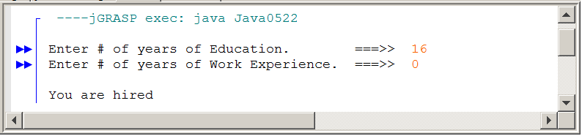
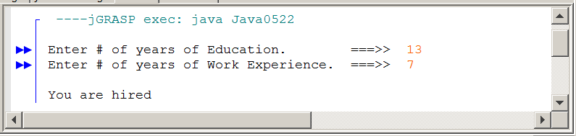
Figure 5.24 Continued
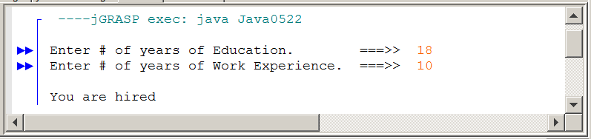
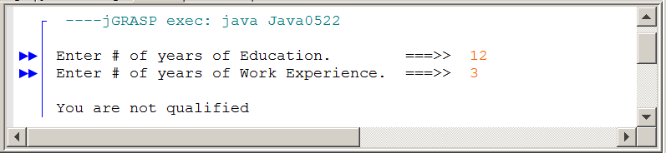

The or Operator
A | B | A or B
T | T | T
T | F | T
F | T | T
F | F | F

The or operator is quite relaxed. Three out of four possible combination give the desired true result. In this case the only combination that prevents your future employment happens if you have neither a degree nor experience.

The next example, program Java0523.java, in figure 5.25, is almost identical to the previous program. The only difference is that now the compound statement is decided by a logical and. Java uses two ampersands && to indicate a logical and. Most of the operators used by Java follow the pattern started with C.

The logical and is far more demanding. There are four possible hiring combinations, and just like the truth table demonstrates, only one will qualify. A person must have the proper education and also the required work experience. The repeated truth table verifies that there is only one hiring opportunity with the logical and operator.

Figure 5.25
// Java0523.java
// This program demonstrates compound decisions with the logical and ( && ) operator.

import java.util.Scanner;

public class Java0523
{
public static void main (String[ ] args)
{
Scanner input = new Scanner(System.in);

System.out.print("Enter # of years of Education. ===>> ");
int education = input.nextInt();
System.out.print("Enter # of years of Work Experience. ===>> ");
int experience = input.nextInt();
System.out.println();

if ((education >= 16) && (experience >= 5))
System.out.println("You are hired");
else
System.out.println("You are not qualified");
}
}

Figure 5.25 Continued
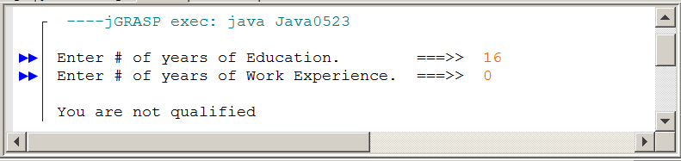
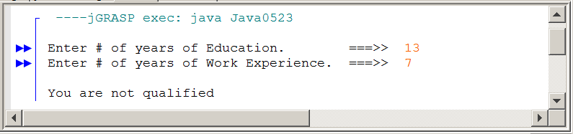
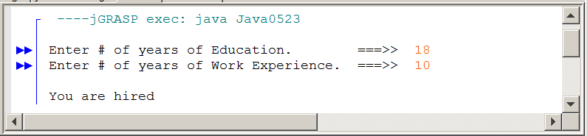
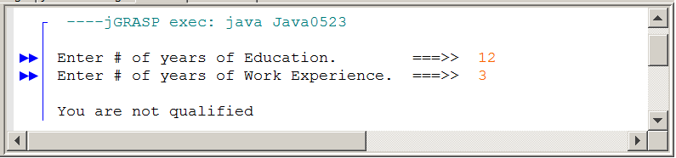

The and Operator
A | B | A and B
T | T | T
T | F | F
F | T | F
F | F | F

Logical Operators in Java
Java uses || to indicate a logical or.
Java uses && to indicate a logical and.
Java uses ! to indicate a logical not.
Java uses != to indicate a logical xor.

5.14 Program Input Protection

One of the most common Boolean laws used in introductory computer science is DeMorgan’s Law. An earlier section demonstrated this law with truth tables. Let us start by looking at program Java0524.java, in figure 5.26, which shows one approach that uses Boolean logic properly. The purpose of the program is to make sure that proper input is entered from the keyboard. This program example could be part of any type of survey or record that asks the program user to enter his or her gender. The program is expected to prevent any entry, except one of the characters M or F.

The compound decision first considers what the proper input should be. Then a set of parenthesis is placed around the desired M or F condition. The not decides if the condition is not the desired one. Check the program out and notice the combination of the or and the not.
Detecting an input error is only the first part of input protection. The second is to force the user to reenter the information. The do…while loop is perfect for this. This postcondition loop is guaranteed to execute at least once – which is good because even if the user enters the correct information, they still need to enter it once. If the information is incorrect, the loop repeats. Note that the if statement and the while statement have the exact same compound condition.

Figure 5.26
// Java0524.java
// This program demonstrates program input protection with a compound condition.
// The <do...while> loop forces the user to re-enter when data is invalid.

import java.util.Scanner;

public class Java0524
{
public static void main (String[ ] args)
{
Scanner input = new Scanner(System.in);

char gender;
do
{
System.out.print("\nEnter Your Gender. ===>> ");
gender = input.nextLine().charAt(0);
System.out.println();

if (!(gender == 'M' || gender == 'F'))
{
System.out.println("Invalid Gender Entered: " + gender);
System.out.println("You must enter M or F.");
}
}

while (!(gender == 'M' || gender == 'F'));

if (gender == 'M')
System.out.println("Your gender is Male.");
else
System.out.println("Your gender is Female.");
System.out.println("You may proceed.");
}
}

Figure 5.26 Continued
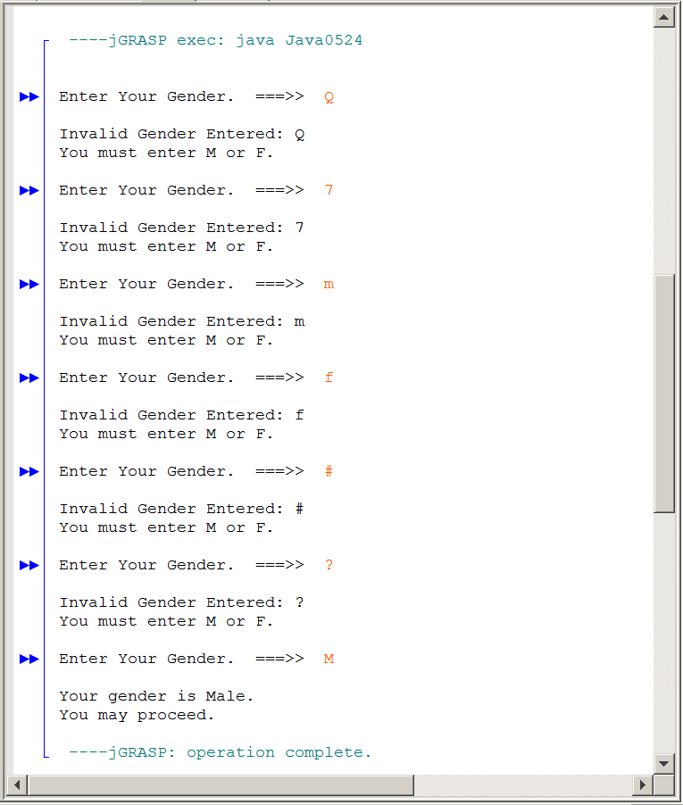

Notice that program Java0524.java, as it is written will only accept upper-case letters M or F. Lower-case m or f is not accepted, just like any other erroneous input. How can you change the program to address that issue?

Program Java0525.java, in figure 5.27, does almost the same thing as the previous program. The only difference is a boolean variable is used. Note how the boolean variable makes the program more readable and eliminates the redundant code as well. The program is also improved to allow lower-case entry.
Figure 5.27
// Java0525.java
// This program uses a <boolean> variable to make the program more readable.
// The program also handles lower-case input for gender.

import java.util.Scanner;

public class Java0525
{
public static void main (String[ ] args)
{
Scanner input = new Scanner(System.in);
char gender;
boolean genderInvalid;
do
{
System.out.print("Enter Your Gender. ===>> ");
gender = input.nextLine().charAt(0);
System.out.println();

genderInvalid = !(gender == 'M' || gender == 'F' || gender == 'm' || gender == 'f');

if (genderInvalid)
{
System.out.println("Invalid Gender Entered: " + gender);
System.out.println("You must enter M or F.");
}
}
while (genderInvalid);

if (gender == 'M' || gender == 'm')
System.out.println("Your gender is Male.");
else
System.out.println("Your gender is Female.");
System.out.println("You may proceed.");
}
}

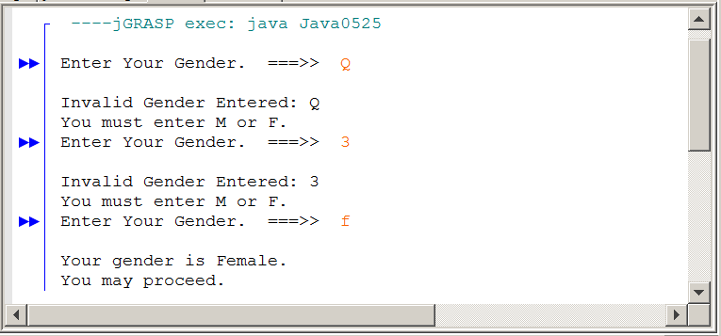
Some time ago, you learned about several properties of mathematics. The Commutative Property of Addition and The Associative Property of Multiplication are just a couple. One of those laws was The Distributive Property of Multiplication over Addition. This rule basically says that A(B + C) = AB + AC. You may even have used this rule to do mental math. For example: 3 * 24 = 3 * (20 + 4) = 3 * 20 + 3 * 4 = 60 + 12 = 72.

Since students are so familiar with the distributive property, they sometime apply it to areas where it does not belong. This is demonstrated by program Java0526.java, in figure 5.28. The statement !(gender == 'M' || gender == 'F') was changed to (gender != 'M' || gender != 'F'). This seems like a logical way to distribute the not through the compound condition. When you run the program, you will see that it is now impossible to enter proper input. Even when you enter an 'M' or an 'F' the program will not accept it.

Figure 5.28
// Java0526.java
// This program attempts to "distribute the not" through the compound condition.
// The program does not function properly because DeMorgan’s Law was not considered.

import java.util.Scanner;

public class Java0526
{
public static void main (String[ ] args)
{
Scanner input = new Scanner(System.in);
char gender;
boolean genderInvalid;
do
{
System.out.print("\nEnter Your Gender. ===>> ");
gender = input.nextLine().charAt(0);
System.out.println();
genderInvalid = (gender != 'M' || gender != 'F');
if (genderInvalid)
{
System.out.println("Invalid Gender Entered: " + gender);
System.out.println("You must enter M or F");
}
}
while (genderInvalid);

if (gender == 'M')
System.out.println("Your gender is Male.");
else
System.out.println("Your gender is Female.");
System.out.println("You may proceed");
}
}

Figure 5.28 Continued
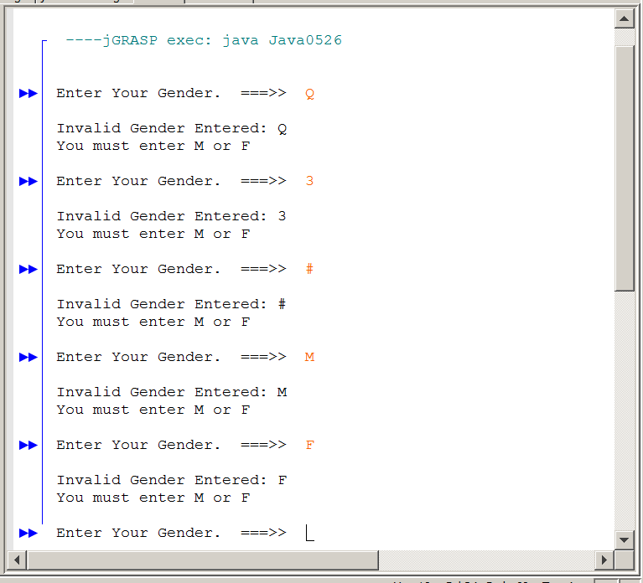

You may wonder why this program goes on forever and will not accept any input, even with an entry of an 'M' or an 'F'. Look at the statement
gender != 'M' || gender != 'F'.

When gender is 'M' the first half of the compound condition, gender != 'M', may be false, but the second half, gender != 'F', is true. Since the OR operator is used, the enter expression is true. In fact, it will always be true.

The problem with this program, is that it does not take DeMorgan's Law into consideration. Take a look at DeMorgan's Law again. The compound decision that checks for correct gender !(gender == 'M' || gender == 'F') is logically equivalent to not(A or B) which, according to DeMorgan’s Law is equal to not A AND not B. This means you essentially can distribute the not, but you must also change the OR to AND (or vice versa). This was shown earlier in the chapter with truth tables. You now see that an actual program also proves the correctness of DeMorgan's Law. Program Java0527.java, in Figure 5.29, applies DeMorgan’s Law to the previous program and gets the same proper input protection.
DeMorgan’s Law Repeated
not(A or B) = not A and not B same as ~(A + B) = ~A * ~B
not(A and B) = not A or not B same as ~(A * B) = ~A + ~B

Figure 5.29
// Java0527.java
// This program fixes the error of the previous program by properly using DeMorgan's Law.

import java.util.Scanner;

public class Java0527
{
public static void main (String[ ] args)
{
Scanner input = new Scanner(System.in);

char gender;
boolean genderInvalid;
do
{
System.out.print("\nEnter Your Gender. ===>> ");
gender = input.nextLine().charAt(0);
System.out.println();

genderInvalid = (gender != 'M' && gender != 'F');

if (genderInvalid)
{
System.out.println("Invalid Gender Entered: " + gender);
System.out.println("You must enter M or F");
}
}
while (genderInvalid);

if (gender == 'M')
System.out.println("Your gender is Male.");
else
System.out.println("Your gender is Female.");
System.out.println("You may proceed");
}
}

Figure 5.29 Continued
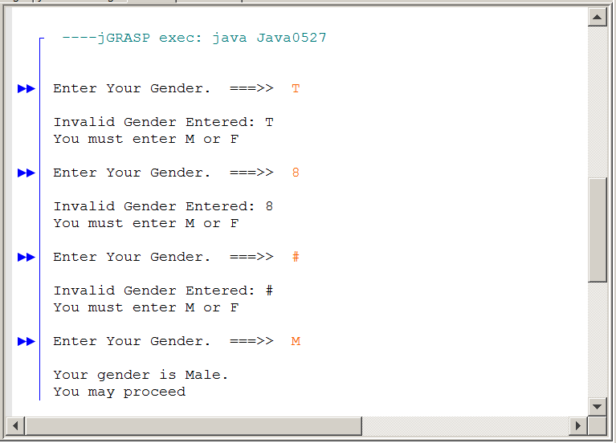

5.15 Short-Circuiting

Java is pretty clever and takes advantage of something called short-circuiting with compound conditions. The name is very appropriate if you think why we use the term short circuit with electricity. Electric current takes a path that travels to some appliance like a freezer, television or a light bulb. The path traveled by the electricity through the wires and the appliance is called a circuit. The appliance will only operate properly is a complete circuit exists. Sometimes, wires may be faulty and insulation is missing that causes a short circuit. Current jumps across the wires and a circuit is completed before the appliance is reached. In such a case a fuse burns or a circuit breaker is switched off to prevent fire damage from the overheated circuits.

The concept applies to computer science decisions as well. A situation exists that stops the normal path in favor of a shorter path. Consider the following, rather complicated, Boolean expression:

A and ( (A or B) and (B or C) and (A or C) or ((B and C) or (A and B)))

This expression can be quite an unpleasant truth table. Now suppose that it is known that A equals false. Is it necessary to evaluate the entire expression? No, it is not, because the and logical operator guarantees that the final outcome will always be false. In this case we can short-circuit the evaluation. Similar logic applies with or. If it is given that A equals true then the entire expression will evaluate to true. Once again it is not necessary to consider the rest of the expression.

A or ( (A or B) and (B or C) and (A or C) or ((B and C) or (A and B)))

The next two program examples will not only involve compound decisions, but they will also demonstrate that short-circuiting is performed by Java. Each program call uses a method, called isEven, shown in figure 5.30. This method is called from the conditional statement.

Calling a method inside a conditional statement is perfectly legal since it is a return method. Return methods return values. You have seen return methods that return integers and real numbers. Method isEven returns true or false, since it is a boolean return method.

The purpose of the method is to return true if the method argument number is even and false if number is odd. The method intentionally displays some output so that you can see when isEven is called. Using this method will provide evidence about Java's short-circuiting habits.

Figure 5.30
public static boolean isEven(int number)
{
System.out.println();
System.out.println("Calling isEven Method");
System.out.println();
if (number % 2 == 0)
return true;
else
return false;
}

Program Java0528.java, in figure 5.31, requests two integers from the keyboard, The two entered numbers are used in the parameters of the isEven method calls. Now Java claims that it will not consider evaluating a complete compound condition if true or false can be guaranteed without moving on. We can test this theory by running the program and seeing if one or both methods are called.

Figure 13.16
// Java0528.java
// This program uses "short circuiting" and uses the isEven
// method to demonstrate short circuiting with logical or.

import java.util.Scanner;

public class Java0528
{
public static void main (String[ ] args)
{
Scanner input = new Scanner(System.in);
System.out.print("Enter number 1 ===>> ");
int n1 = input.nextInt();
System.out.print("Enter number 2 ===>> ");
int n2 = input.nextInt();
if (isEven(n1) || isEven(n2))
System.out.println("At least one number is even.");
else
System.out.println("Both numbers are odd.");
}

public static boolean isEven(int number)
{
System.out.println();
System.out.println("Calling isEven Method");
System.out.println();
if (number % 2 == 0)
return true;
else
return false;
}
}

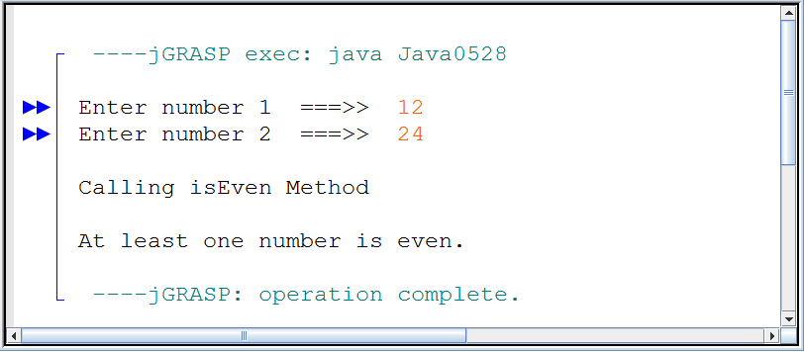
Figure 5.30 Continued
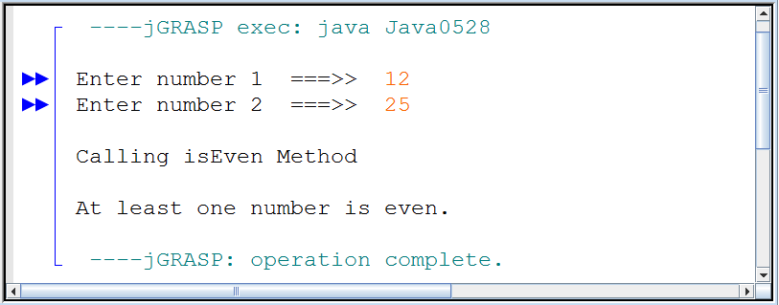

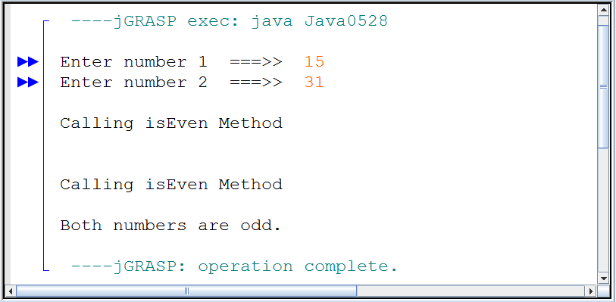

The output of program Java0528.java does not disappoint us. As anticipated, only the first part of the compound condition, (isEven(N1) || isEven(N2)) is evaluated when it is established that the whole condition must be true. This is proven by the single call to the isEven method when the first number entered is an even number.

Program example Java0529.java, in figure 5.31, is very similar to the previous program, and it uses the same isEven method. This time short-circuiting is tested with a logical and. The concept of short-circuiting is the same, but in this case Java stops evaluating when it is established that the first condition is false.

You will find in future chapters that short-circuiting becomes a useful tool in preventing incorrect program executions. In particular, short circuiting with the logical and will be used frequently.

Figure 5.31
// Java0529.java
// This program uses "short circuiting" and uses the isEven
// method to demonstrate short circuiting with logical and.

import java.util.Scanner;

public class Java0529
{
public static void main (String[ ] args)
{
Scanner input = new Scanner(System.in);
System.out.print("Enter number 1 ===>> ");
int n1 = input.nextInt();
System.out.print("Enter number 2 ===>> ");
int n2 = input.nextInt();
if (isEven(n1) && isEven(n2))
System.out.println("Both numbers are even.");
else
System.out.println("At least one number is odd.");
}

public static boolean isEven(int number)
{
System.out.println();
System.out.println("Calling IsEven Method");
System.out.println();
if (number % 2 == 0)
return true;
else
return false;
}
}

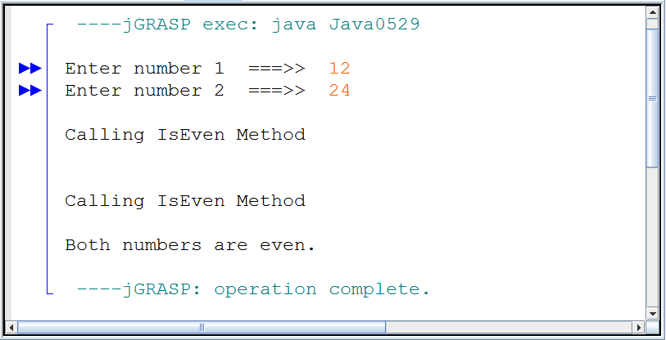

Figure 5.31 Continued
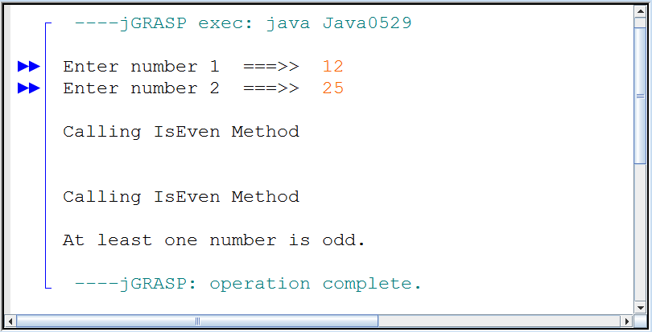

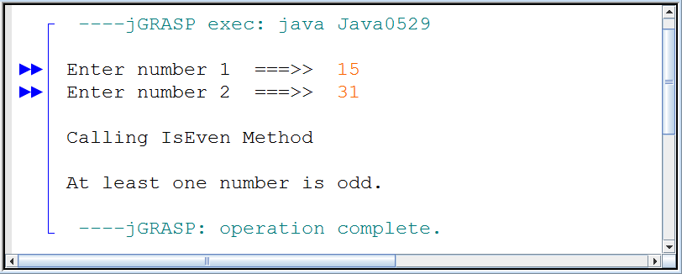

5.16 Summary

This chapter introduced controls structures. Prior to this chapter, programs were strictly controlled by a sequence of program statements. Java, like most programming languages, provides three types of control structures. There are simple sequence, selection and repetition control structures.

Control Structures and Programming
Arithmetic is basic to all mathematics.

Complex Calculus problem may produce wrong results, not because the calculus is misunderstood, but because the necessary arithmetic is wrong.

Simple sequence provides control by the order in which program statements are placed in a program. This is very important, but provides very limited control. It is neither possible to make any decisions nor is it possible to repeat any block of program statements.

Selection provides three types of decision control structures. There is one-way selection with if, two-way selection with if..else and multiple-way selection with case..break. If the break keyword is not used with a multi-way structure, the output will not be correct. After the first match all other case are executed.

Iteration also provides three types of loop control structures. There is fixed iteration with for, pre-condition iteration with while and postcondition iteration with do..while.

It is possible to use multiple conditions with control structures and it is also possible to nest one control structure inside another control structure. When compound logical conditions are used the laws of Boolean Algebra apply, which are not the same as conventional Algebra I laws.

Truth tables help to explain the result of compound conditions that use any of the Boolean operators, or, and, xor, not. An important rule about truth tables is that that different Boolean expressions with equivalent truth tables are equivalent.

An important Boolean Algebra Law is DeMorgan's Law. This law is used frequently to prevent erroneous program input. Remember when parentheses are removed that or becomes and, while and becomes or.

Combining control structures, especially repetition, with various Graphics commands can create very interesting graphics displays. The lab assignment of this chapter showed how multiple straight lines, displayed close together, can create the illusion of a curved line.

DeMorgan’s Law
not(A or B) = not A and not B same as ~(A + B) = ~A * ~B
not(A and B) = not A or not B same as ~(A * B) = ~A + ~B

AP® Examination Alert
These control structures will be tested on the AP®CS Examination:

if one-way selection
if..else two-way selection
for fixed iteration
while pre-condition iteration

AP® Examination Alert
These control structures will not be tested on the AP®CS Examination:

switch..case multiple-way selection
do..while post-condition iteration

